High Density Mapping for Ablation of Atrial Tachyarrhythmias in Adults with Congenital Heart Disease
Authors: Anudeep Jassal MD, Naomi Kertesz MD , Jennifer Russell MSN RN CNL, Tamara Ackley RN, Steven Kalbfleisch MD, Curt Daniels MD, Anna Kamp MD MPH
Presenting Author: Anudeep Jassal, MD, Pediatric Cardiology Fellow

Background:
Ablation of atrial tachyarrhythmias in adults with congenital heart disease (ACHD) is complex. Three dimensional electroanatomic mapping systems (EAM) is recommended for this population. High density mapping with the PentaRay® (Biosense Webster) has not been studied in this group. We proposed the addition of high density mapping with PentaRay® mapping catheter, in addition to 3D EAM, is safe and effective for ablation of atrial tachyarrhythmias in adults with CHD.

Methods:
This is a single center retrospective cohort study of ACHD patients who underwent ablation for atrial tachyarrhythmias from 2013 – 2017. The two study cohorts were: 1) ablation with EAM and 2) ablation with EAM with addition of PentaRay® mapping catheter (EAM+P).

Results:
Fifteen ablations were performed in 13 patients using standard EAM, and 11 ablations were performed in 10 patients using EAM+P. There was no difference in mean age (38 vs 33 years, p=0.08) or complexity of CHD (66% vs 64% complex CHD, p=1). Median fluoroscopy time was longer in EAM group (26.2 mins, IQR 12-54min) compared to EAM+P group (5min IQR 1-7.5min) p=0.0017. A higher number of sheaths were used for EAM cases compared to EAM+P (p=.00142). Although not statistically significant, the EAM group had longer EP procedure time compared to EAM+P group: median (IQR) of 207 min (148-381min) vs. 187 min (94-201min). There was no difference in acute success rates of ablation: 93% success in EAM and 100% success in EAM+P. There were no procedural related complications in either group.

Conclusions:
This is the first study to demonstrate the safety and efficacy of high density PentaRay® mapping catheter in addition to 3D mapping system for atrial tachyarrhythmia ablations in ACHD patients. Use of PentaRay® mapping catheter demonstrated shorter fluoroscopy time and decrease number of access sites needed with a trend toward shorter procedure time.

Word count: 297
Figure: 1

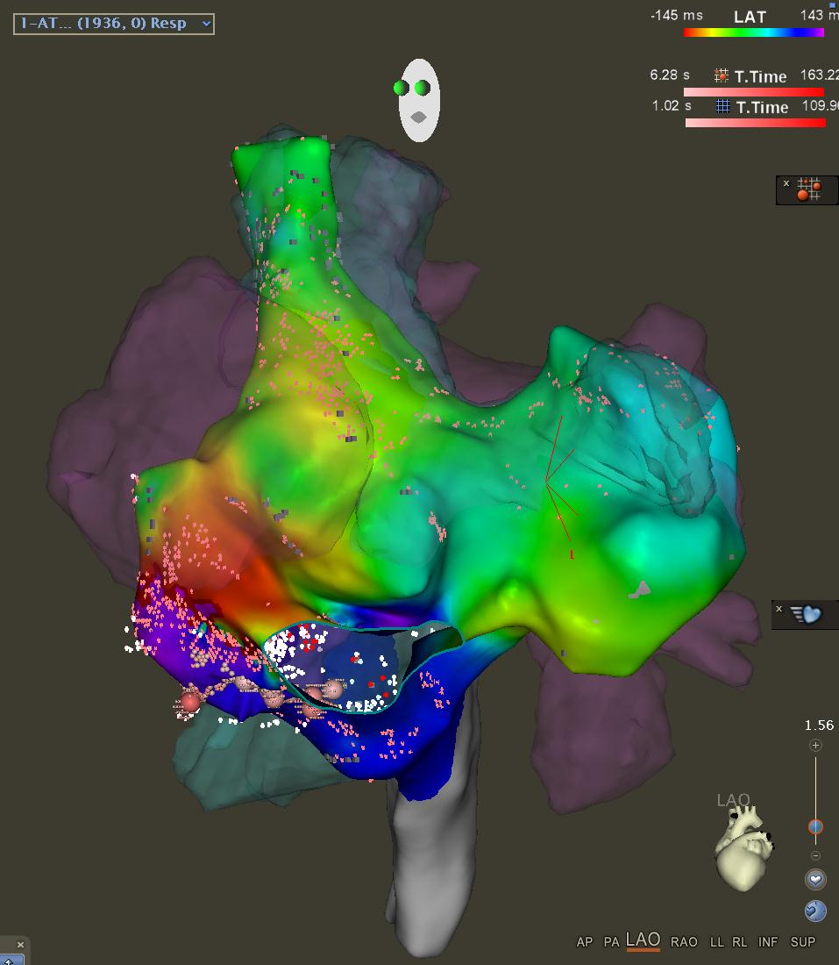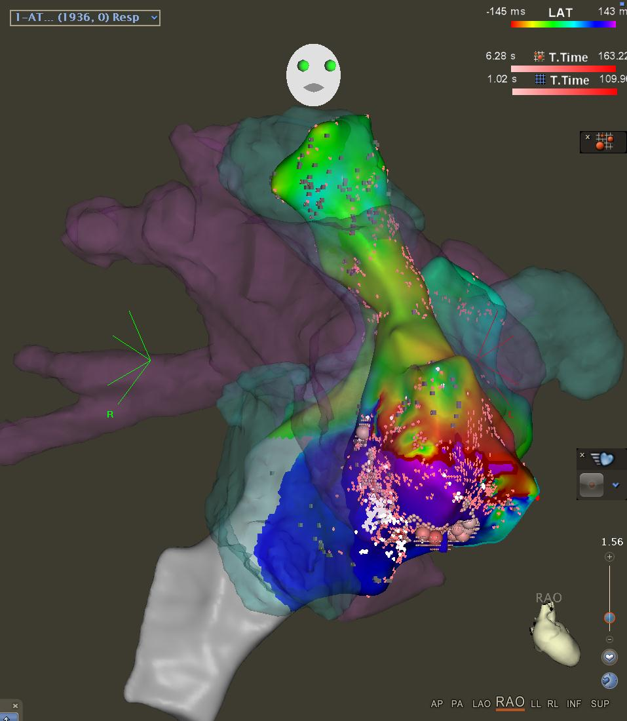
Figure 1. Activation map in a patient with D-Transposition of the Great Arteries s/p Mustard with CMRI overlay, demonstrated early meets late activation, consistent with intra atrial reenterant tachycardia, 1942 activation points in 13:52 minutes (A) RAO View (B) LAO View

