Title: First in man, minimally invasive VATS placement of steroid eluting epicardial leads.
Authors:
Von Bergen NH, Fitch Z, Nellis J, Torres J, Klapper J, Zebulon S, Choi A, McCarthy D, Hermsen JL, Turek JW.
Duke University, Raliegh NC
The University of Wisconsin – Madison
Introduction: Younger patients, or those with vascular abnormalities who require permanent pacemakers may have limitations precluding transvenous lead placement. Minimally invasive options for sew-on epicardial lead placement have not existed, requiring patients to undergo lead placement via sternotomy or thoracotomy. Using an adjustable shaft, dual needle suturing device, we describe the first-in-man experience of placing steroid eluting sew-on epicardial leads in three patients.
Case reports: Three patients underwent VATS procedure for epicardial lead placement. Two patients were 9 year old females with heart block due to lupus or CHD. The third patient was a 76 year old male with non-ischemic cardiomyopathy in need of resynchronizatin in whom CS access could not be obtained.
A 9 year old female was taken to the operating room, placed under general anesthesia, positioned in left lateral decubitus, and selectively intubated allowing isolated left lung ventilation. Two five millimeter ports were placed in the right 4th and 8th intercostal spaces, and a third, one centimeter, working port was placed in the 6th intercostal space (Figure 1a). A dual needle suturing device was used to initiate a horizontal mattress stitch using 3-0 suture in the right atrium via the 6th intercostal space (Figure 2). A steroid-eluting bipolar lead (Medtronic 4968) was then introduced over the suture and secured in place using a titanium fastening device (Cor-Knot, LSI Solutions, Victor, NY) (Figure 3a). These steps were repeated for the second portion of the steroid eluting lead. The lead was tested and showed adequate sensing and pacing. The proximal end of the atrial lead was passed through the abdominal wall at the level of the diaphragm, and tunneled laterally to the existing pacemaker pocket in the left upper quadrant. Atrial and ventricular pacing was interrogated and proved exceptional. The patient was discharged home three days later.
The second patient, also a 9 year old female was placed in right lateral decubitus position and single-lung ventilation was employed. 5mm ports were placed in the 5th and 9th intercostal spaces along the left posterior axillary line, and a 1cm port placed in the 7th intercostal space. The 5th interspace port was used for pericardium and lung retraction, the 9th interspace port was the camera port, and the 7th interspace port was the working port (Figure 1b). The pericardium was taken down posterior to the phrenic nerve. The lead was attached to the LV in a similar fashion as above, then tunneled to the pocket and attached to the new generator. All leads functioned well, with stable pacing thresholds on the original leads, and a low LV pacing threshold.
The third patient, a 76 year old veteran with non-ischemic cardiomyopathy and renal failure was in need of cardiac resynchronization. The approach was similar to patient 2. A bipolar steroid-eluting epicardial lead was attached in the same fashion using the dual needle suturing and titanium fastening devices. Pacing thresholds were below 2.5V. This patient had a pre-existing right pre-pectoral device. The LV lead required an extender and was tunneled retrosternal by L VATS and retrieved and brought into the pacer pocket by R VATS. The patient was discharged 5 days later mostly owing to his dialysis schedule.

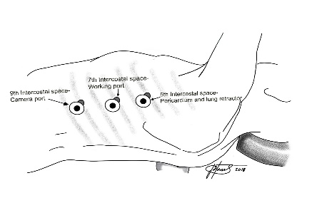
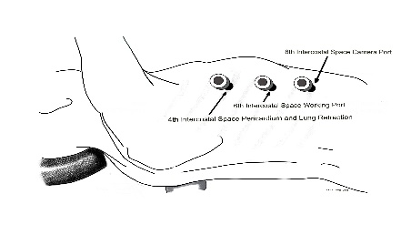
Figure1: Location of port access VATS procedure.

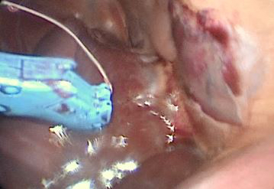
Figure 2: Dual needle suture device approaching the right atrium

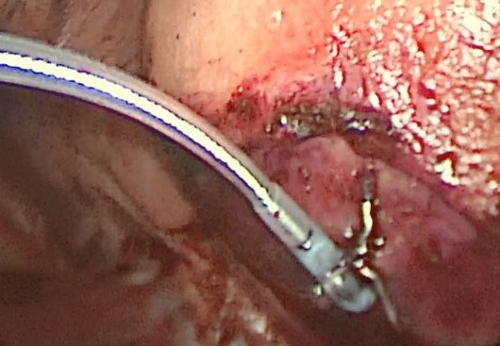
Figure 3a on of the RA epicardial lead attachment sites 3b. One of the LV lead attachment sites
