Activity Recommendations in Children who have had Cardiac Surgery
Jesse M. Boyett Anderson (medical student); Megan A. Moreno; John S. Hokanson

Clinicians, parents, and patients decide which sorts of physical activity are appropriate for children who have had cardiac surgery and when children should return to normal activities after surgery. Current recommendations are limited and tailored to adolescents and young adults.
We surveyed Midwest Pediatric Cardiology Society members regarding resources used to develop activity recommendations, recommended time to return to normal activities after cardiac surgery, and physical activity recommendations for 8-year-old children with varied cardiac histories (no known cardiac defect, repaired coarctation with normal blood pressure, Tetralogy of Fallot with good hemodynamic repair, single ventricle after Fontan, repaired VSD with implanted pacemaker, and mechanical valve anticoagulated with warfarin) .
Forty-six individuals completed the survey (response rate = 9.6%). Most were male (69%), physicians (88%) practicing non-interventional cardiology (82%) with an average of 13 years in practice.
Respondents used patient testing (58%), institutional policies (67%), the opinions of colleagues or experts (73%), published guidelines (76%), patient symptoms (95%), and hemodynamics (100%) and when formulating recommendations.
Recommended timing of return to normal activity following cardiac surgery was quite variable (see figure 1). There was some consensus regarding physical activity recommendations in the long term. All respondents recommended children on anticoagulation avoid motorsports and sports with high risk of collision (i.e., football and hockey), however, 42% indicated they would discourage participation in sports with a lower risk of collision, such as soccer, basketball, tennis or softball. Such variability persisted across cardiac history.
Post-surgical and long-term activity recommendations for children younger than 12 years who have had cardiac surgery are variable, reflecting a paucity of evidence-based guidelines for the management of these patients. Future studies should explore the risks and benefits of various activity types and the timing of return to full activity in children who have had cardiac surgery.
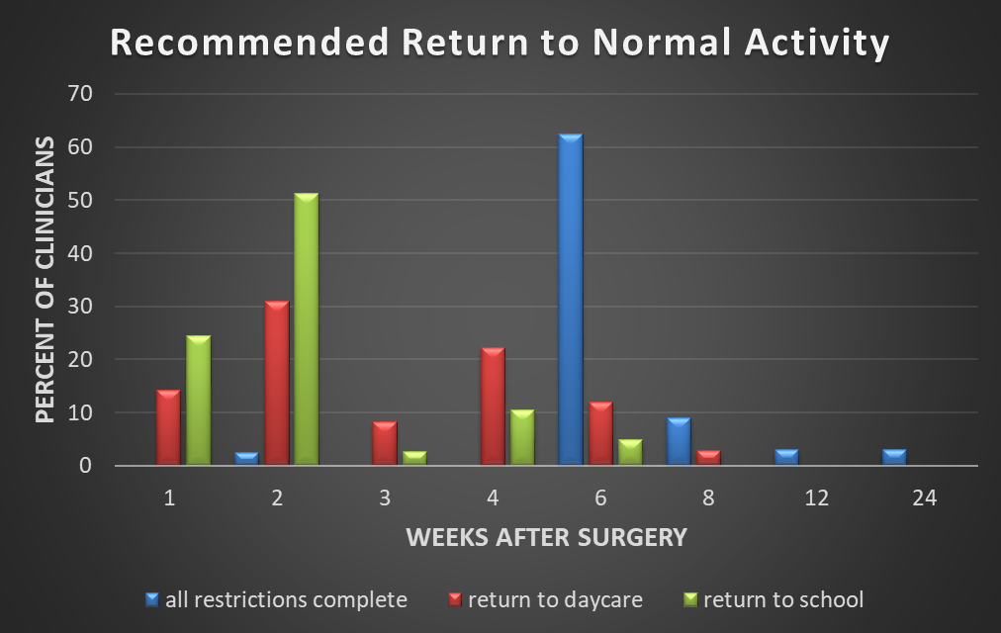
Figure 1: Length of post-surgical activity restrictions recommended by clinicians, in weeks.

